Tinghe Cui & Jiazhen Lin

2/21/2021

CS460 PA1

* E/R diagram

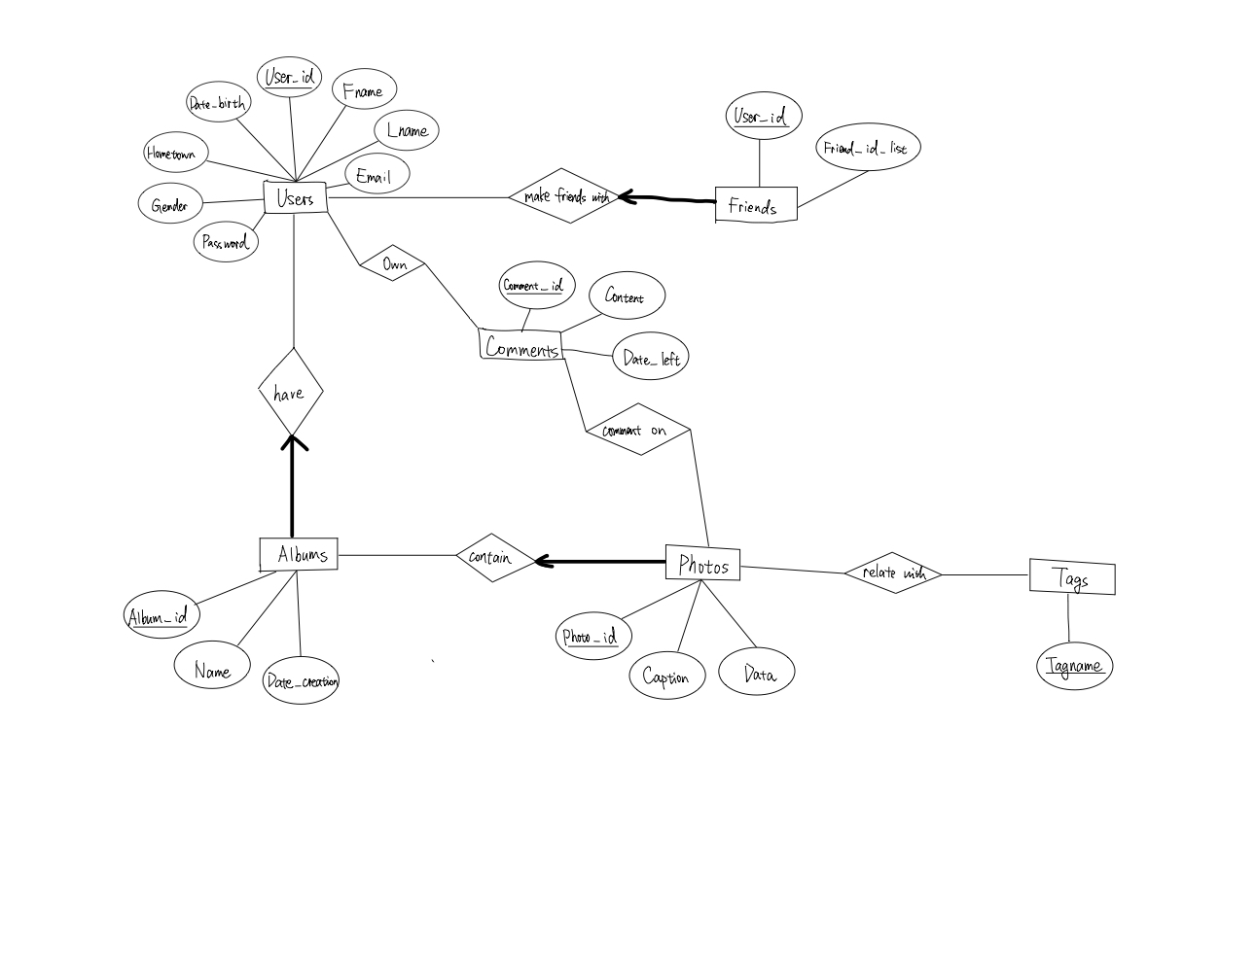

* Relational schema

CREATE TABLE Users (User_id CHAR(20) PRIMARY KEY,

Fname CHAR(50),

Lname CHAR(50),

Email VARCHAR(200),

Date_birth DATE,

Hometown VARCHAR(100),

Gender CHAR(10),

Password VARCHAR(100));

CREATE TABLE have(

User_id CHAR(20)

album_id CHAR(20)

PRIMARY KEY ( User_id, make_album_id),

FOREIGN KEY(User_id) REFERENCES Users(User_id);

FOREIGN KEY(album) REFERENCES album(album_id));

CREATE TABLE make_Friends_with (

User_id CHAR(20)

make_friend_id CHAR(20)

PRIMARY KEY ( User_id, make_friend_id),

FOREIGN KEY(User_id) REFERENCES Users(User_id);

FOREIGN KEY(friends) REFERENCES Friends(User_id));

CREATE TABLE contain(

photo_id CHAR(20)

tag_name CHAR(20)

PRIMARY KEY ( photo_id, tag_name),

FOREIGN KEY(photo_id) REFERENCES photo(photo_id);

FOREIGN KEY(tag_name) REFERENCES tag(tag_name));

CREATE TABLE relate_to(

photo_id CHAR(20)

album_id CHAR(20)

PRIMARY KEY ( photo, make_album_id),

FOREIGN KEY(photo_id) REFERENCES photo(photo_id);

FOREIGN KEY(album) REFERENCES Album(album_id));

CREATE TABLE comment_on(

photo_id CHAR(20)

comment_id CHAR(20)

PRIMARY KEY ( photo_id, comment_id),

FOREIGN KEY(photo_id) REFERENCES Photo(photo_id);

FOREIGN KEY(comment_id) REFERENCES Comment(comment_id));

CREATE TABLE comment_on(

user_id CHAR(20)

comment_id CHAR(20)

PRIMARY KEY ( user_id, comment_id),

FOREIGN KEY(user_id) REFERENCES user(photo_id);

FOREIGN KEY(comment_id) REFERENCES Comment(comment_id));

CREATE TABLE Friends (User_id CHAR(20) PRIMARY KEY,

Friend_id_list ENUM,

FOREIGN KEY(User_id) REFERENCES Users(User_id));

CREATE TABLE Albums (Album_id CHAR(20) PRIMARY KEY,

Name CHAR(100),

Owner_id CHAR(20),

Date_creation Date,

FOREIGN KEY(Owner_id) REFERENCES Users(User_id));

CREATE TABLE Photos (Photo_id CHAR(20) PRIMARY KEY,

Album_id CHAR(20),

Caption VARCHAR(200),

Data BLOB,

FOREIGN KEY(Album_id) REFERENCES Albums(Album_id));

CREATE TABLE Tags (Tagname VARCHAR(50) PRIMATRY KEY);

CREATE TABLE Comments (Comment_id CHAR(29) PRIMARY KEY

Content TEXT,

Owner_id CHAR(20),

Date_left Date,

Photo_id CHAR(20),

FOREIGN KEY(Owner_id) REFERENCES Users(User_id)

FOREIGN KEY(Photo_id) REFERENCES Photos(Photo_id));

* Assumptions

Here are some assumptions in our design. We assume that we create a unique id for each user, photo, and album. Each user has a weak entity called friend list. We assume the comments can be set for users or photos, so the comments can be linked with users or photos. What’s more, we assume the length of the e-mail address is no more than 200 characters and the length of comment content is no more than 65535 characters. Comment is linked with the user and the photo, what means the user’s comment belongs the photo. We also assume that the photo is bond with the album. We assume one photo belongs to one album. Thus, each photo is a weak entity. If an album is deleted, the photo will also be deleted.